
RAMAIAH
Institute of Technology
USN | 1 | M | S

(Autonomous Institute, Affiliated to VTU)
(Approved by AICTE, New Delhi & Govt. of Karnataka) Accredited by NBA & NAAC with ‘A’ Grade

MAKEUP EXAMINATIONS – FEBRUARY 2020
Program | : | B.E.: Electrical and Electronics Engineering | Semester | : | V
Course Name | : | Control Systems | Max. Marks | : | 100
Course Code | : | EE52 | Duration | : | 3 Hrs

Instructions to the Candidates:
- Answer one full question from each unit.
- Suitably assume any missing data.

 |  | UNIT- I
1. | a) | Differentiate open loop and closed loop systems with atleast three examples for each. | CO1 | (08)
 | b) | Derive transfer function of field controlled DC servo motor. | CO1 | (12)
2. | a) | Obtain the i) Force - current analogy ii) Force – Voltage analogy of the mechanical system shown in Fig.2(a).  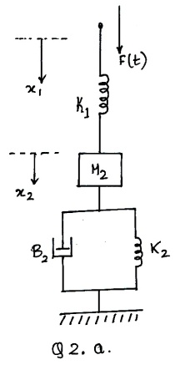  Fig 2.(a) | CO1 | (12)
 | b) | Derive transfer function of armature controlled separately excited DC servo Motor. | CO1 | (08)
 |  | UNIT- II
3. | a) | Define: i) Peak Overshoot ii) Peak Time with respect to an under damped system. Derive the expression for the same. | CO2 | (10)
 | b) | For the closed loop system shown in Fig.3b  - Draw SFG  ii) Find the TF= 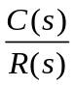  - Find the settling time for system response to be within 2% of the final value when unit step disturbance D(s) occurs.  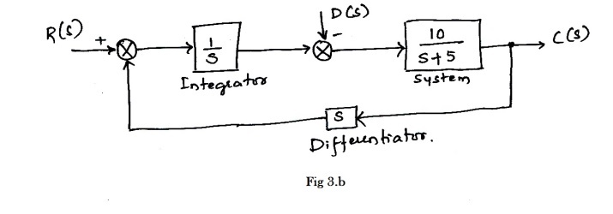 | CO2 | (10)
4. | a) | Obtain the transfer function 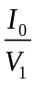for the circuit shown in Fig.4a.  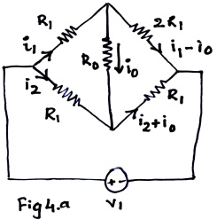 | CO2 | (10)
 | b) | Define steady state error,? With usual notations, derive the expression for steady state error and positional error constant of a negative feedback system. | CO2 | (10)
 |  | UNIT- III
5. | a) | Sketch the root locus plot of the system whose OLTF is given as 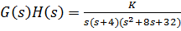. Comment on its stability. | CO3 | (08)
 | b) | What are the difficulties in R-H stability criterion? Explain how you can overcome them. | CO3 | (06)
 | c) | Consider a fourth-order system with the C.E. , state whether the system is stable or not. | CO3 | (06)
6. | a) | sketch the root locus plot of a unity feedback system whose open loop transfer function is | CO3 | (15)
 | b) | A feedback system has open loop transfer function of . Determine the maximum value of K for the closed loop system to be stable. | CO3 | (05)
 |  | UNIT- IV
7. | a) | Using Nyquist stability criterion, find the range of K for closed loop stability. The OLTF is given by 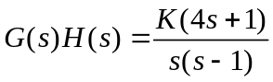 | CO4 | (10)
 | b) | A unit step input is applied to unity negative feedback system having OLTF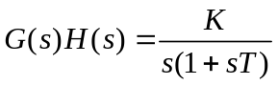.  Determine K and T to have peak overshoot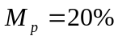 and resonant frequency 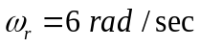. Also find resonant peak 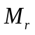. | CO4 | (10)
8. | a) | Using Nyquist stability criterion, investigate the closed loop stability of a negative feedback control system whose open loop transfer function is given by G(S)H(S)=100(1+5s)/[s⁴(s+1)]. | CO4 | (12)
 | b) | Consider G(S)H(S)=1/[s(1+T₁s)(1+T₂s)]. Draw the polar plot. | CO4 | (08)
 |  | UNIT- V
9. | a) | Obtain the Bode plot of unity negative feedback system, whose OLTF is 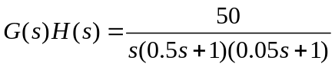 . Hence find the stability of the system. | CO4 | (12)
 | b) | Explain the need for designing of a compensator with at least two relevant practical examples. | CO5 | (08)
10. | a) | Obtain the Bode plot of unity negative feedback system, whose OLTF is 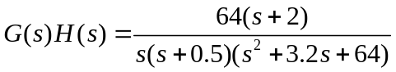. Hence find the stability of the system. | CO4 | (14)
 | b) | Explain the need for designing of a compensator with one practical example. | CO4 | (06)

****************

